Web Application (Student Club) Feature Plan
Requirement: Develop a student club website so that students can easily browse and join the club.

Phase 1: Basic Features
User Authentication & Authorization:
Sign up: users can create an account with their email and password.
Log in: users can log in with their email and password.
Users can reset their password.
Different roles: Implement different user roles (User, Club Manager, Admin) with different permissions.
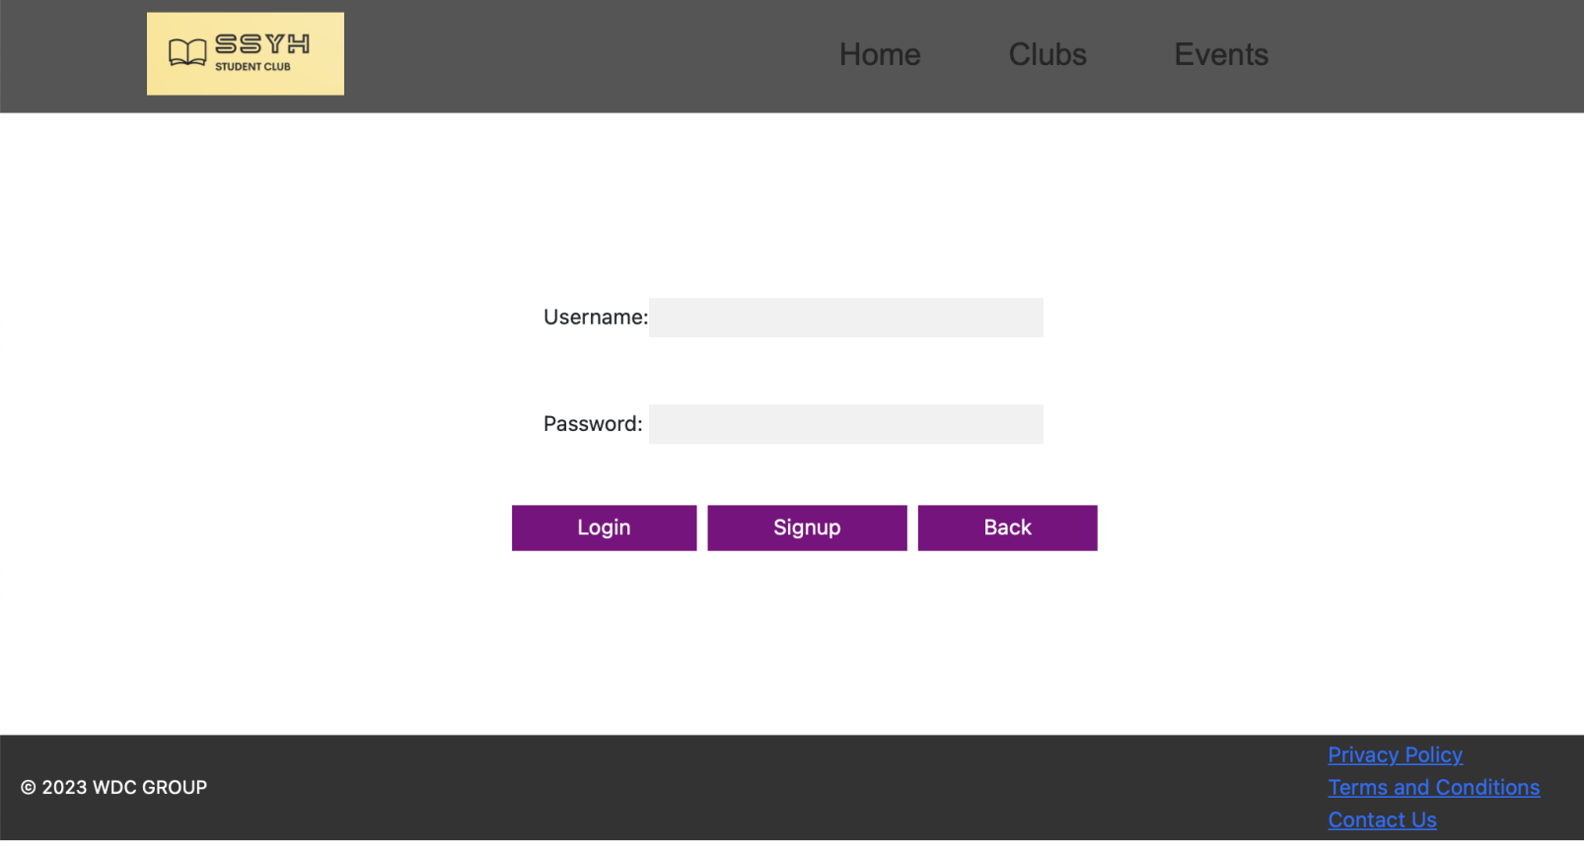
Profile Management:
Users can create and update their profile information (name, school, etc.).
Users can view other members' profiles.

Club Membership:
Join a Club: Users should be able to join any club.
View Club Updates: Users should be able to view updates from the clubs they've joined.
RSVP to Club Events: Users should be able to see upcoming events and RSVP.
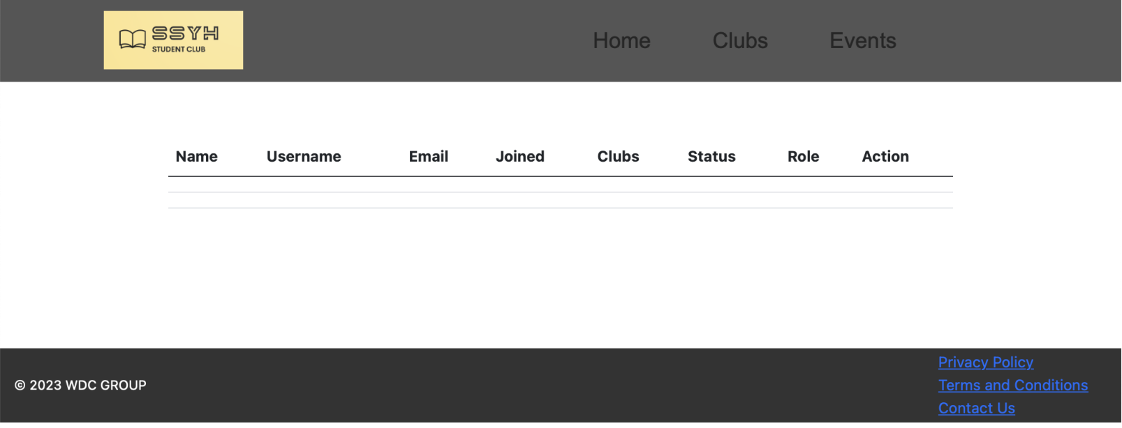
Phase 2: Advanced Features
Membership Management:
Users can apply to join the club.
Club admins can approve or reject membership applications.
Club Management (for Club Managers):
View Members: Club Managers should be able to view their club's members.
Accept/Remove member: Club Managers should be able to accept users join club requests or remove membership of users from the club.
Post Updates: Club Managers should be able to post updates, both publicly and privately to their members.
Manage Club Events: Club Managers should be able to create and update club events.
View RSVPs: Club Managers should be able to see who has RSVP'd for an event.

System Management (for System Admins):
Manage Users: Admins should be able to manage all users.
Manage Clubs: Admins should be able to manage all clubs.
Sign Up Other Admins: Admins should be able to sign up other admins.

Notifications:
Users receive notifications for new events, project updates, and membership status changes.
Public View:
Public Information: Users without accounts should be able to view public information and updates for a club.

 | Features | Description
1 | Responsive Web Design | create optimal viewing experiences for users across different devices and screen sizes.
2 | The scrollable navigation bar that moves along with the webpage | allows users to quickly access the menu options
3 | automatic scrolling when the 'Enter' key is pressed | allows users to quickly view the page
4 | the dropdown shows more things | keeping the page simple

Phase 3: Future Features
Email Notifications (Special Feature):
Sign Up for Email Notifications: Users should be able to sign up to receive email notifications from clubs.
Customise Notifications: Users should be able to choose which types of email notifications are sent for each club and which clubs they receive those notifications from.

Document and track progress:
Meet weekly with team members to discuss project progress and next steps.

Timetable plan:
Clubs information(create, delete, etc): 2 weeks
User registration and login: 1 week
Admin: 1 week
Checkout: 1 week
Test plan:
Functional Testing: Ensure that each feature works as per the specification requirements.
Performance testing: Testing the website's response time, scalability, and security.
User experience testing: Test each feature from a user perspective to ensure its ease of use and understanding.

Final review and testing：
Ensure that the whole site meets expectations and works as per the specifications.
Conduct a final user experience test to ensure students can easily use the site and identify any issues and fix them promptly.

